
∑.E.M.
Releases notes v1.05

Releases notes
v1.05
Bugs & Change 3
Improvement 4
Add the total delivered in € on the dashboard Blade #160 4
Add version link in menu Blade#161 4
The add line form does not display well on mobile Blade #169 5
Have the delivered curve on the dashboard #170 6
Move the "user list" link from the setting menu #172 6
UI improve #182 6
Put the buttons of the new 'object' in the card #184 7
Finish the time management page #147 7
Manage the end of internal orders #156 8
Have the ability to make announcements on the dashboard #149 8
Manage leave requests #146 9
human resources page #145 9
Employment contract #113 9
User Role #74 10

Bugs & Change
- #150 print/order/manufacturing => 500 Oops! Internal Server Error.
- #151 Column not found: 1054 Unknown column 'orders.id' in 'order clause'
- #152 Creating an invoice does not update the delivery line
- #153 Commands are detected while the list is empty
- #155 If the client is not active, it falsifies the client selection list
- #157 Delevery note and invoice report not display well
- #164 Error on gantt page bug
- #166 Remove double card style
- #167 "Internal Order" is diplay on quote PDF
- #168 Leaves request tab is active
- #171 Invoice value in dashboard is not impediment
- #174 production.ERROR: Trying to access array offset on value of type null
- #176 Column not found: 1054 Unknown column 'code' in 'order clause'
- #177 Column not found: 1054 Unknown column 'orders.id' in 'order clause
- #178 Column not found: 1054 Unknown column 'companies_id' in 'order clause'
- #179 Check sort field
- #180 Method Illuminate\Http\Request::status does not exist.
- #183 Wrong title on NC
- #186 Change Quote to Quotes in menu
- #185 Empty lines
- #187 Create Edit/View/Delete components

Improvement

Add the total delivered in € on the dashboard Blade #160

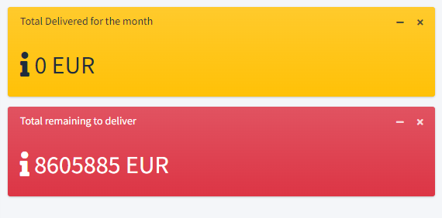

Add version link in menu Blade#161
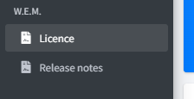

The add line form does not display well on mobile Blade #169

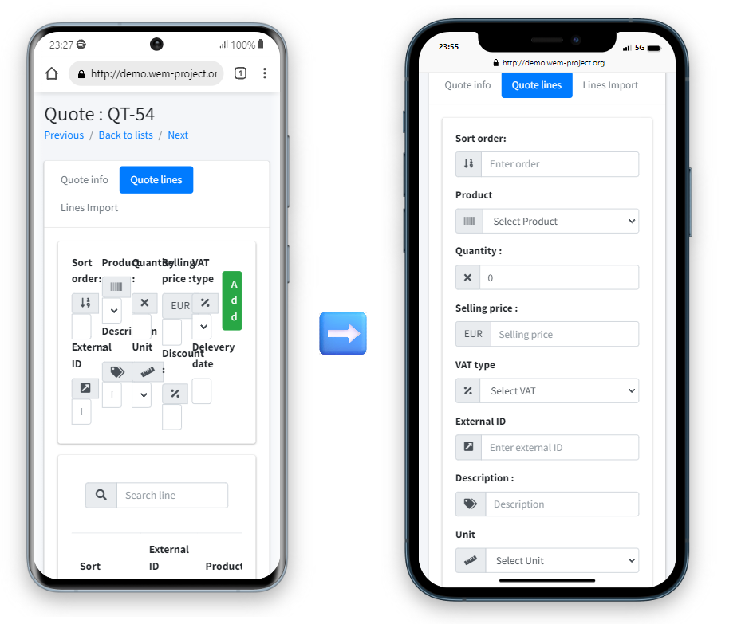

Have the delivered curve on the dashboard #170

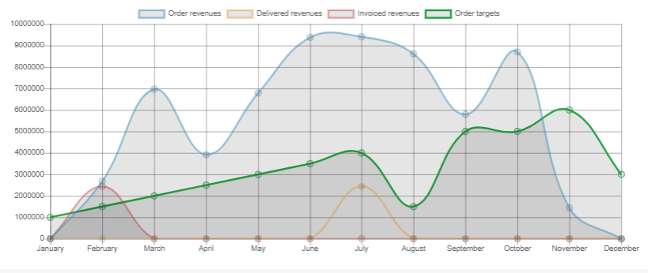

Move the "user list" link from the setting menu #172
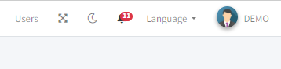

UI improve #182

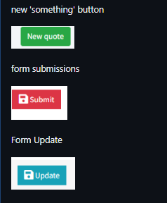

Put the buttons of the new 'object' in the card #184

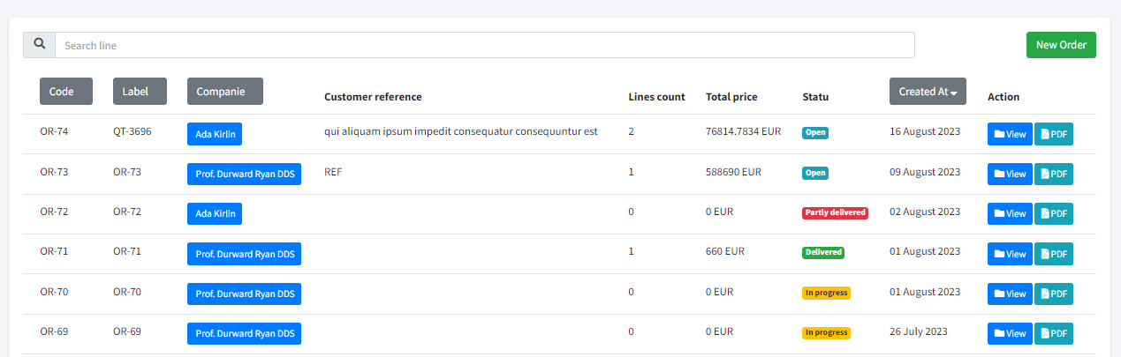

Finish the time management page #147

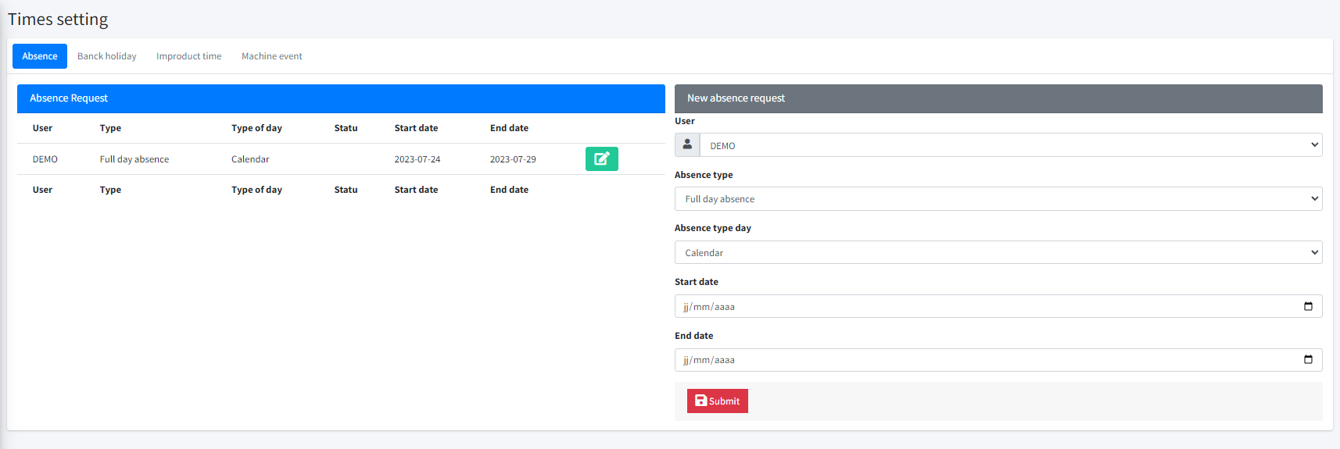

Manage the end of internal orders #156

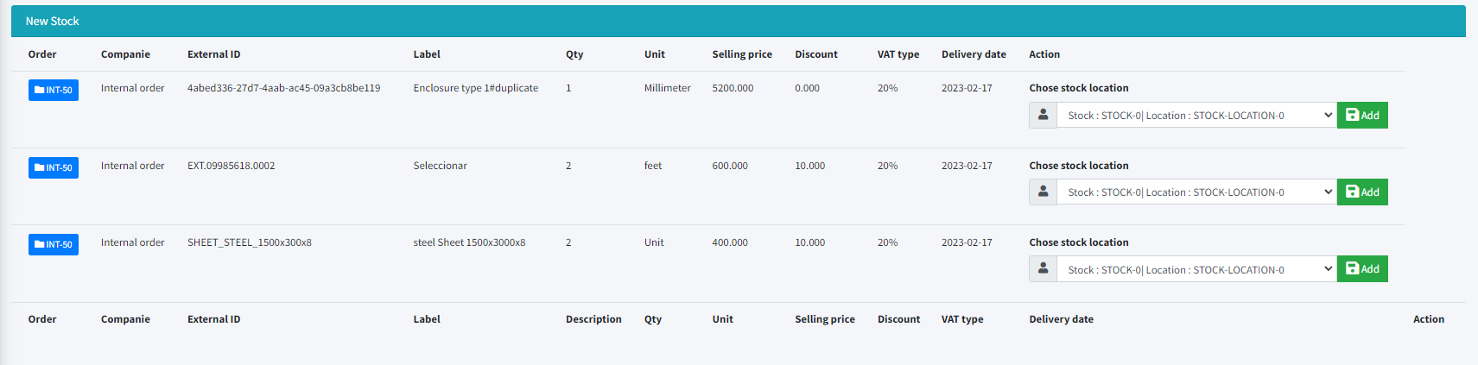

Have the ability to make announcements on the dashboard #149

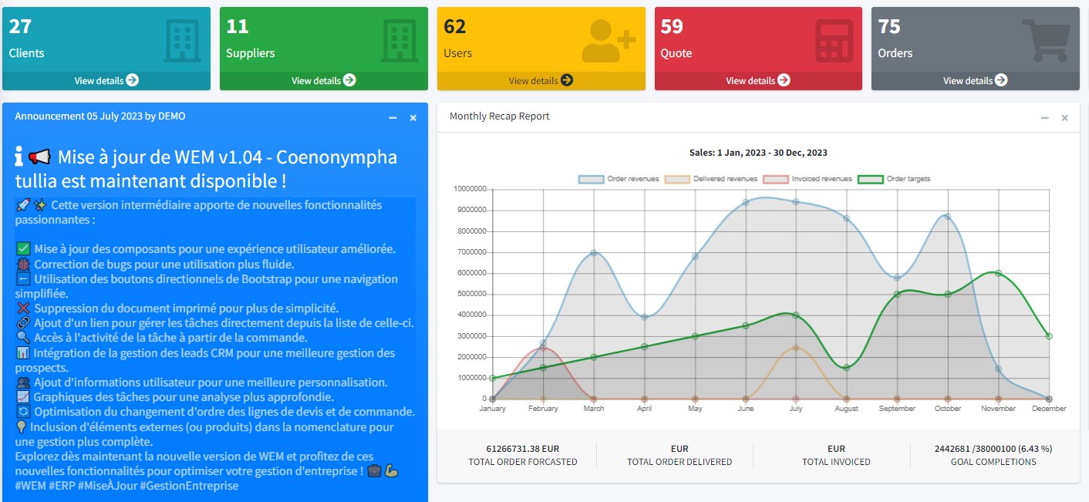

Manage leave requests #146

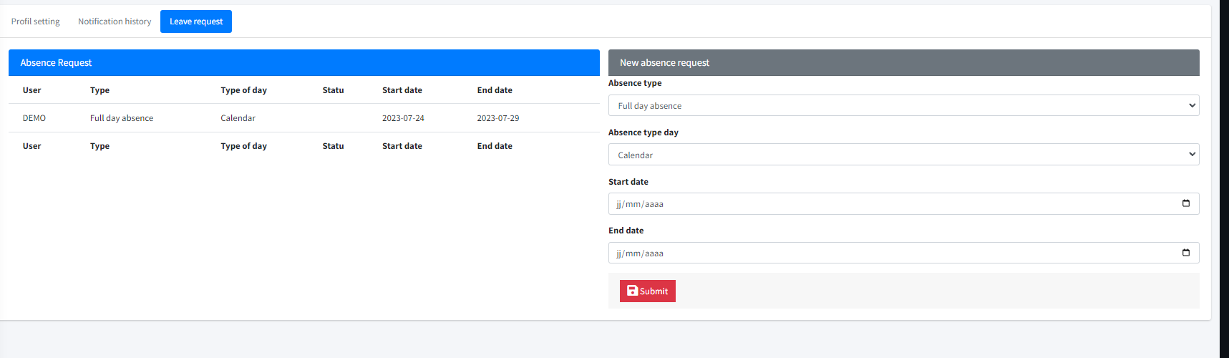

human resources page #145

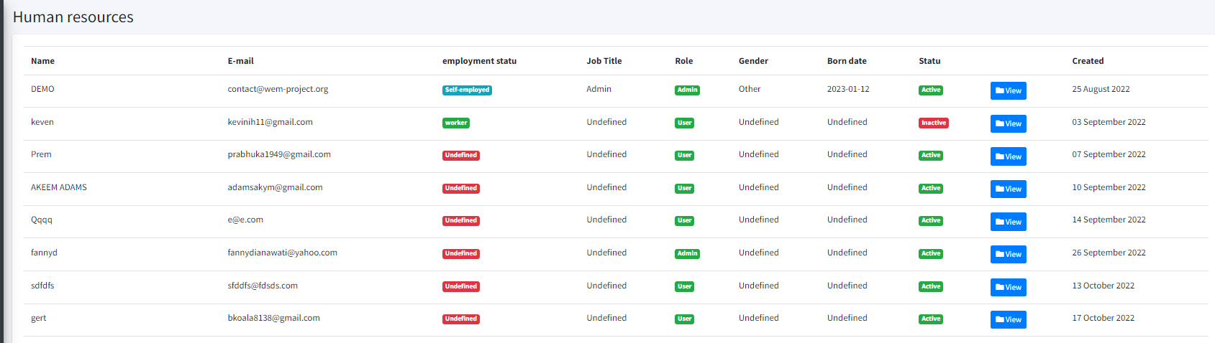

Employment contract #113

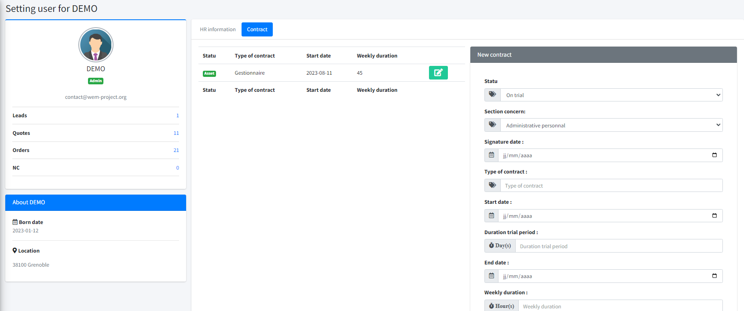

User Role #74
